QUESTION 1

Write a function that takes one number as an argument and return their factorial.

**INPUT**

number=int(input("Enter the number for factorial="))

def fact():

fac=1

i=1

while i<=number:

fac=fac*i

i=i+1

return fac

fact()

**OUTPUT**

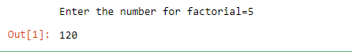

**OUESTION 2**

**Write a Python program to create the multiplication table (from 1 to10) of a number.**

number_table=int(input("enter the number for table: "))

i=1

while i<=10:

ans= i*number_table

print(number_table,"*",i,"=",ans)

i=i+1

**OUTPUT**

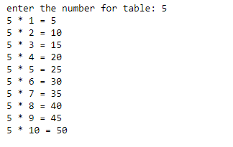

**QUESTION 3**

**Modify a calculator you made in the last lab. This time your function ask user to**

**enter the number and the operation you want to perform (+,-,*,/) after the**

**operation is performed your program should ask the user whether you want to**

**continue (Y/N)? your program will exit only when user enter “N”**

def calculator():

x = int(input('enter the value of x: '))

y = int(input('enter the vaue of y: '))

operation = input('''

Enter Operation(+,-,,/,*''')

if operation == '+':

print(x + y)

elif operation == '-':

print(x - y)

elif operation == '*':

print(x * y)

elif operation == '/':

print(x / y)

else:

print('not operator valid.')

again()

def again():

call_again = input('''

Do you want to calculate again?

Please type Y for YES or N for NO.

''')

if call_again.upper() == 'Y':

calculate()

elif call_again.upper() == 'N':

print()

else:

again()

calculator()

**OUTPUT**

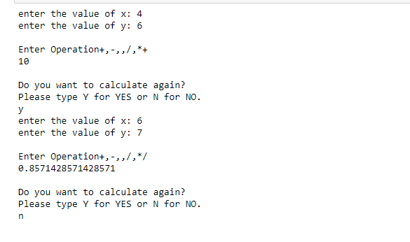

**OUESTION 4**

**Write a function that takes two numbers as an argument and return their LCM.**

def lcm(x, y):

if x > y:

greater = x

else:

greater = y

while(True):

if((greater % x == 0) and (greater % y == 0)):

lcm = greater

break

greater += 1

return lcm

x=13

y=15

print("The L.C.M. is", lcm(x, y))

**OUTPUT**



**OUESTION 5**

Write a function that takes two numbers as an argument and return their HCF

(Highest Common Factor) /GCD (Greatest Common Divisor).

def hcf(x,y):

if (x == 0):

return y

if (y== 0):

return x

if (x == y):

return x

if (x > y):

return hcf(x-y, y)

return hcf(x, y-x)

a = 100

b =25

if(hcf(a, b)):

print('HCF of', a, 'and', b, 'is', hcf(a, b))

else:

print('not found')

**OUTPUT**

